**PROJECT 3**

**ASHISH SANGHVI**

**ashishsa**

To check whether the given relation is in 3rd Normal Form we check each of the tables are in the 3rd Normal Form.

In general the properties of tables in third normal form are the following:

1. It has to be in the 2nd Normal Forms
2. The Transitive Functional Dependency Of Non-Prime Attributes on any super key must be removed.

TABLE Users:- Its in 3rd NF as non key attributes display name, account password and user type is dependent on email_id.

TABLE Professor,Staff and Student:- Its in 3rd NF as key attributes email_id is unique and referenced from user. The department number is referenced from the departments table.

TABLE department:- Its in 3NF as it contains unique department number(Primary Key) and the non key attribute department name is dependent on the department number.

TABLE program:- Its in 3NF as it contains unique program name and id. The program name is dependent on the program id. There is unique dept no referenced from departments table.

TABLE majors:- Its in 3NF as it contains unique student email id. The major department is unique dept no referenced from departments table.

TABLE prog_pursues_majors:- Its in 3NF as it contains (student email id, major dept) referenced from majors, program id from program and the combination forms a super key with no non-prime attributes. The majordept might be different from the dept major of program as student might be pursuing program that’s different from his majors dept.

TABLE semester:- Its in 3NF as it contains unique combination of year and season offered which is unique and forms super key.

TABLE registers:- Its in 3NF. The register_id is Primary key and unique. There are no transitive relationships between the foreign keys and they are not dependent on each other thus does not violate the 3NF rule.

TABLE course:- Its in 3NF as course id is Primary Key and course name is dependent on course id. course dept is foreign key.

TABLE pre_req_course:- Its in 3NF. Course id and pre req course id are dependent on each other.

TABLE instructor:- Its in 3NF. Contains Instructor od which is referenced from professor_id as Foreign key and is a Primary key in this table.

TABLE courses_available:- Its in 3NF. Contains (course_id,year_offered,season_offered,session_id) as Primary key and capacity is dependent on this super key.

TABLE enroll:- Its in 3NF. Contains (register_id,course_id,year_offered,season_offered,session_id) as Primary key and subject passed and subject grade is dependent on the super key and there are no transitive relationships.

TABLE instructs:- Its in 3NF. Contains (instructor_email_id,course_id,year_offered,season_offered,session_id) all of which are foreign keys and a combination forms the Primary key and there are no transitive relationships.

TABLE feedback:- Its in 3NF. Contains (instructor_email_id,course_id,year_offered,season_offered,session_id,register_id) ) all of which are foreign keys and a combination forms the Primary key and there are no transitive relationships. The feedback is dependent on the combination of these primary keys.

TABLE ta:-Its in 3NF.Contains (student_email_id,course_id,year_offered,season_offered,session_id) all of which are foreign keys and comination forms a primary key. There are no transitive relationships.

TABLE exam:-Its in 3NF. exam_id is primary key and (course_id,year_offered,season_offered,session_id) are foreign keys and are unique combination. Thus there are no transitive relationships.

TABLE student_takes_exam:-Its in 3NF. Contains (exam_id,register_id,course_id,year_offered,season_offered,session_id) ) all of which are foreign keys and a combination forms the Primary key and there are no transitive relationships. The final_grade is dependent on the combination of the primary keys.

TABLE problems:- Its in 3NF. Contains problem_id as primary key. exam_id is foreign key. Scores is dependent on problem_id and there are no transitive relationships.

TABLE result:- Its in 3NF. Contains (problem_id,exam_id,register_id,course_id,year_offered,season_offered,session_id) all of which are foreign keys and a combination forms the primary key and there are no transitive relationships. The scores is dependent on the combination of the primary keys.

TABLE book:- Its in 3NF. Contains (ISBN) as primary key and (title,pages,publication_date) are dependent on the ISBN and there are no transitive relationships

TABLE author:-Its in 3NF. author_id is primary key and author_name depends on author_id.

TABLE library:- Its in 3NF. university_id is primary key.

TABLE physical_library:- library_id is primary key. university_id is foreign key. There are no transitive relationships.

TABLE copies:- book_id is primary key.(ISBN,date_of_purchase,book_id,price) are non-key attributes and its in 3NF.

TABLE writes:- Combination of (author_id,ISBN) is the primary key.

TABLE borrow:- Combination of (book_id,borrower_email_id) is primary key. The combination of (issue_date, return_date, extended_date ,extension_requested ,returned) is non key attribute and there are no transitive relationships. Its in 3NF.

Thus the Relational Data Base Table in PROJECT1 is in 3rd NORMAL FORM.

2A) An unregistered student enrolls CSE 560 in 2020 Fall

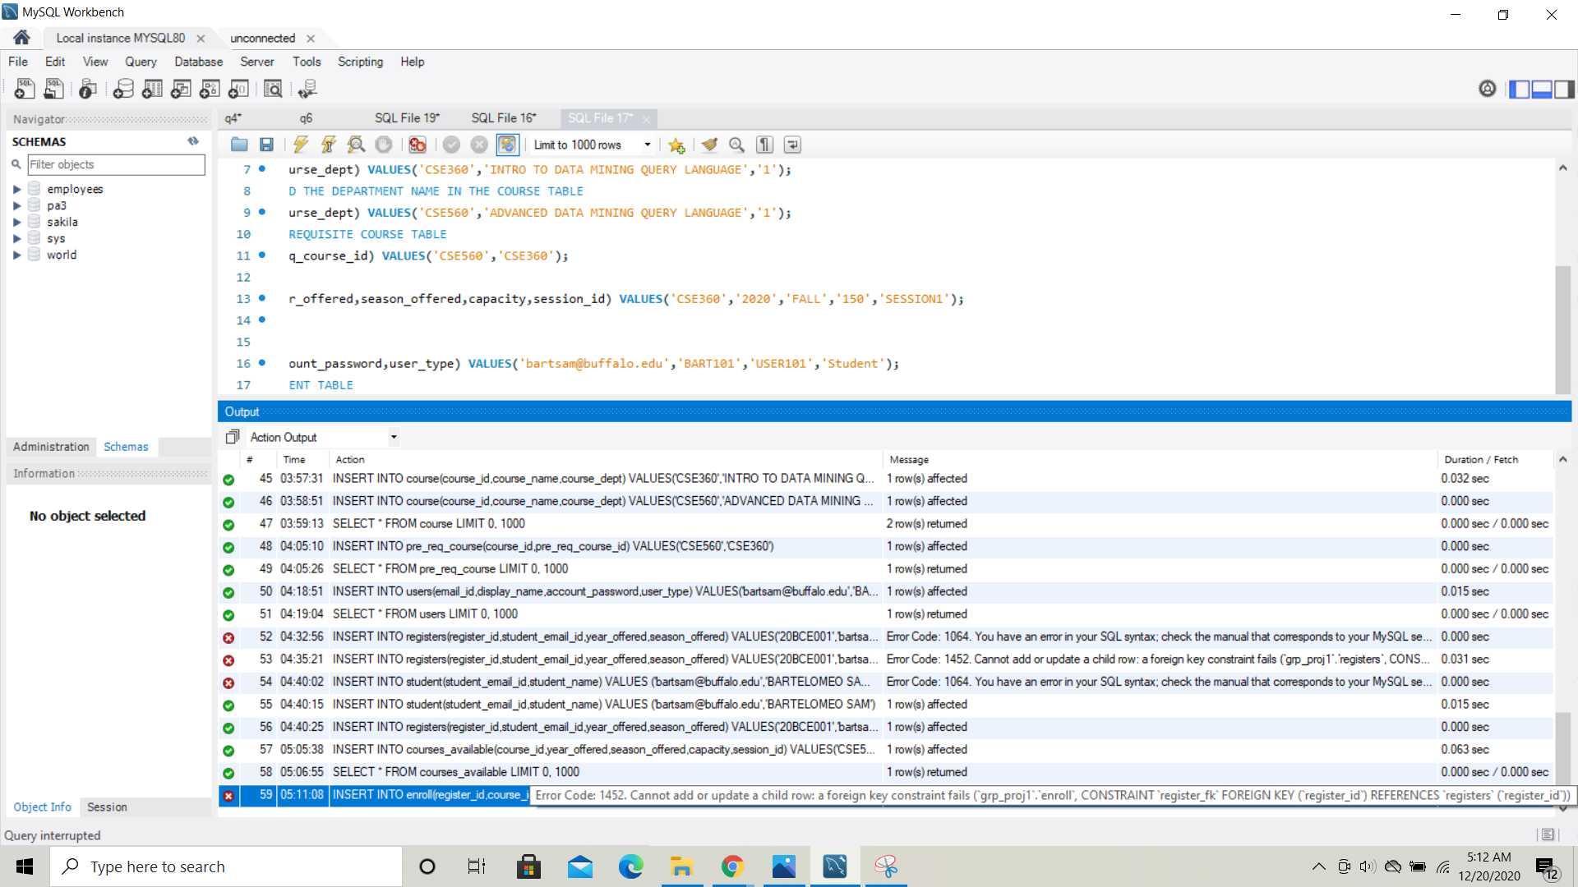

WE GET ERROR CODE 1452 WHICH STATES THAT FOREIGN KEY RELATIONSHIP CONSTRAINT FAILS IF WE TRY TO REGISTER AN UNENROLLED STUDENT.

2B) A registered student enrolls CSE 560 in 2020 Fall but does not pass the prerequisite course, CSE 360, of CSE 560.

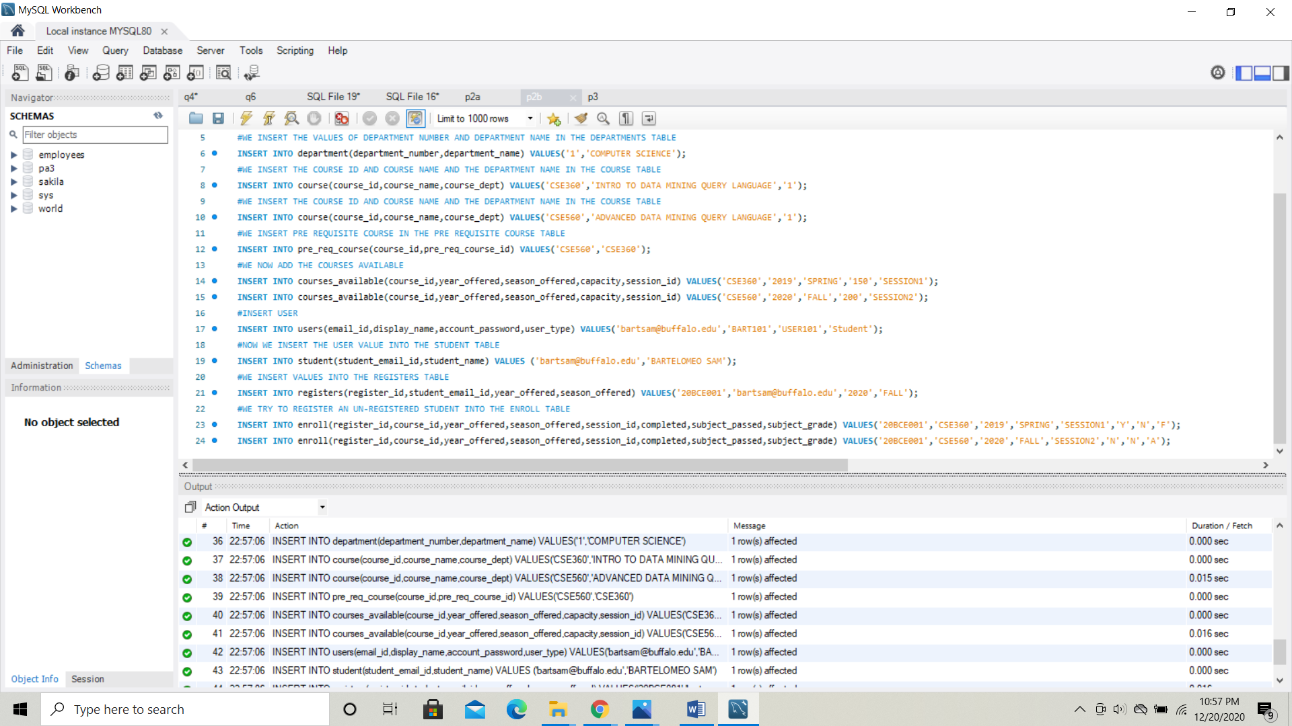

THE STUDENT IS ABLE TO REGISTER THE COURSE CSE 560 AS LONG AS WE HAVE REGISTERED FOR CSE 360 EVEN IF HE/SHE HASNOT PASSED THE EXAM. INCASE IF YOU ADD USER THAT HAS NOT TAKEN THE PRE REQUISITE COURSE THEN THE RELATIONAL TABLE SHOULD GIVE AN ERROR.

1. DELETE TO REMOVE USER FROM USER TABLE.

The DELETE USER IS NOT SUPPORTED IN OUR RELATIONAL DATABASE SCHEMA AND IT THROWS ERROR AS WE HAVE NOT SPECIFIED THE DELETE SEQUENCE IN THE DESIGN OF THE SCHEMA. BY ADDING (**ON** **DELETE** **CASCADE**) IT HELPS YOU TO DELETE THE INSTANCES OF THE USER FROM ALL THE TABLES WHERE THE ELEMENTS FROM THE PARENT TABLE ARE REFERENCED AS A FOREIGN KEY.

CURRENT ERROR:- CANNOT UPDATE OR DELETE A PARENT ROW AS A FOREIGN KEY CONSTRAINT FAILS.

